**A DASHBOARD FOR SERVICES UTILIZATION**

**AT AIRPORTS USING IoT ANALYTICS**

**A Mini Project Report**

Submitted to the Faculty of Engineering of

**JAWAHARLAL NEHRU TECHNOLOGICAL UNIVERSITYKAKINADA,**

**KAKINADA**

In partial fulfillment of the requirements for the award of the Degree of

**BACHELOR OF TECHNOLOGY**

In

**COMPUTER SCIENCE AND ENGINEERING**

By

**S. B. MUKESH V.TEJA SRI**

**(19481A05M9) (19481A05O9)**

**P. PRAVEEN KUMAR REDDY**

**(19481A05K1)**

Under the Esteemed Guidance of

**Mr. J. N. V. R. SWARUP KUMAR**

Assistant Professor, Department of CSE



**DEPARTMENT OF COMPUTER SCIENCE AND ENGINEERING**

**SESHADRI RAO GUDLAVALLERU ENGINEERING COLLEGE**

**(An Autonomous Institute with Permanent Affiliation to JNTUK, Kakinada)**

**SESHADRIRAO KNOWLEDGE VILLAGE**

**GUDLAVALLERU – 521356**

**ANDHRA PRADESH**

**2021-22**

**SESHADRI RAO GUDLAVALLERU ENGINEERING COLLEGE**

**(An Autonomous Institute with Permanent Affiliation to JNTUK, Kakinada)**

**SESHADRI RAO KNOWLEDGE VILLAGE, GUDLAVALLERU**

**DEPARTMENT OF COMPUTER SCIENCE AND ENGINEERING**



**CERTIFICATE**

This is to certify that the project report entitled **“A DASHBOARD FOR SERVICES UTILIZATION AT AIRPORTS USING IoT ANALYTICS”** is a bonafide record of work carried out by **S. B. Mukesh (198481A05M9), V. Teja Sri (19481A05O9), P. Praveen Kumar Reddy(19481A05K1)** under the supervision of **Mr. J. N. V. R. SWARUP KUMAR** in the partial fulfillment of the requirements for the award of the degree of Bachelor of Technology in Computer Science and Engineering of Jawaharlal Nehru Technological University Kakinada, Kakinada during the academic year 2021-22.

**Project Guide Head of the Department**

**(Mr. J. N. V. R. Swarup Kumar) (Dr. M. BABU RAO)**

**External Examiner**

**ACKNOWLEDGEMENT**

The satisfaction that accompanies the successful completion of any task would be incomplete without the mention of people who made it possible and whose constant guidance and encouragements crown all the efforts with success.

We would like to express our deep sense of gratitude and sincere thanks to **Mr. J. N. V. R. Swarup Kumar**, Assistant Professor, Department of Computer Science and Engineering for his constant guidance, supervision and motivation in completing the project work.

We feel elated to express our floral gratitude and sincere thanks to **Dr. M. Babu Rao**, Head of the Department, Computer Science and Engineering for his encouragements all the way during analysis of the project. His annotations, insinuations and criticisms are the key behind the successful completion of the project work.

We would like to take this opportunity to thank our beloved principal **Dr. G.V. S. N. R. V. Prasad** for providing a great support for us in completing our project and giving us the opportunity for doing project.

Our Special thanks to the faculty of our department and programmers of our computer lab. Finally, we thank our family members, non-teaching staff and our friends, who had directly or indirectly helped and supported us in completing our project in time.

**Team members**

S. B. Mukesh. (19481A05M9)

V. Teja Sri (19481A05O9)

P. Praveen Kumar Reddy (19481A05K1)

**ABSTRACT**

In the present growing world, airports are accommodated with more unused or less frequently used resources. The main idea of this project is to minimize the utilization of unused or less frequently used resources at the airports using barcode scanners.

It is difficult to analyze which resources are in high demand and which have been not used, by using barcode scanners one can analyze and moderate the resources at the airport. This can be achieved based on the barcodes present on the government authorized identities of people such as Passport, Aadhar card, etc., for knowing the utilization of a particular resources at the specified airport.

i

**INDEX**

**TITLE PAGENO**

**ABSTRACT i**

**CHAPTER 1: INTRODUCTION**

* 1. INTRODUCTION 1
  2. EXISTING SYSTEM 1
  3. DISADVANTAGES 1
  4. PROBLEM STATEMENT 1
  5. PROPOSED SYSTEM 2
  6. ADVANTAGES 2

**CHAPTER 2: REQUIREMENT ANALYSIS**

* 1. FUNTIONAL REQUIREMENTS 3
  2. NON FUNTIONAL REQUIREMENTS 3
  3. SOFTWARE AND HARDWARE SPECIFICATIONS 3

**CHAPTER 3: DESIGN**

* 1. SYSTEM ARCHITECTURE 4
  2. UML DIAGRAMS 5
     1. USECASE DIAGRAM 5
     2. CLASS DIAGRAM 6
     3. ACTIVITY DIAGRAM 7
     4. SEQUENCE DIAGRAM 8

**CHAPTER 4: IMPLEMENTATION**

* 1. TECHNOLOGY DESCRIPTION 9
  2. PROCEDURE FOR EXECUTION 10

**CHAPTER 5: TESTING**

* 1. UNIT TESTING 11
  2. INTEGRATION TESTING 12
  3. PERFORMANCE TESTING 13

**CONCLUSION AND FUTURE SCOPE** 14

**BIBILIOGRAPHY** 15

**ANNEXURE – I**

1. SCREENSHOTS 16

**CHAPTER-1**

**INTRODUCTION**

* 1. **INTRODUCTION**

Today the world is growing enormously it might be in finance or in the population. As population is increased in support of it the tourism has also been increased with this directly or indirectly the air transportation is affected in a linear fashion. For the sake of passengers at the airports, many resources had been installed and being installed without any accurate information. This leads to the wastage of economy if the resources are less utilized or not utilized.

* 1. **EXISTING SYSTEM**

Currently there is no existing methodology for this problem. But if we take installation of a service into consideration then, there will be a record of how many number of products have been purchased in the name of service. But there would be no tacking down of how the utilization is been taking place for the particular service at a specified airport.

* 1. **DISADVANTAGES**
* There will be no utilization count for the services at airports.
* Wastage of money on less utilized services at the airports.
  1. **PROBLEM STATEMENT**

There are abundant resources and services available to the passengers at the airports. But a question arises how far they have been utilized? This question comes to mind while investing money on the resources. The resources might be high in demand in a particular airport or least utilized in the other airport. This leads to the wastage of expenditure on resources or the services. This extravagant behavior can be resolved by our project

**“A Dashboard for Service Utilization at airports Using IoT Analytics”**

* 1. **PROPOSED SYSTEM**
* A barcode scanner will be placed at each service in the airport which can be measured.
* The barcode scanner scan’s the Government authorized id cards for the sake of utilizing a service.
* The scanned data will be updated in the database for that particular service if the scanned data is true.
* With the data stored in the database, we would display the stats on the website in visual representation i.e., Pie chart, which states, which airport has utilized the service on a daily or monthly or yearly bases as per the selection done by the local authority.
  1. **ADVANTAGES**
* With the use of barcode scanners, we will know out of how many resources available for a service how many have been used or utilized.
* The output of this work would help the airport authority of India (any county) to minimize the expenditure on unused services and resources.
* The airport authority can transport the resources from one airport to other based on their utilization.

**CHAPTER-2**

**REQUIREMENT ANALYSIS**

* 1. **FUNTIONAL REQUIREMENTS**
* Passport Details Database.
* Barcode Scanner.
* Monitor or LCD or LED screen at a particular service.
* Need constant Internet connection.
  1. **NON FUNTIONAL REQUIREMENTS**
* Easy Usability.
* Accurate Information.
* Less Maintainability.
  1. **SOFTWARE AND HARDWARE SPECIFICATIONS**
* XAMPP Server.
* Text Editor (i.e., Visual Studio).
* Any Browser.
* Languages –HTML5, CSS3, Bootstrap, JS, PHP, MySQL, Google-Charts.
* Operating systems as Windows or Mac.
* Processor – i5.
* RAM – 8GB (minimum).

**CHAPTER - 3**

**DESIGN**

* 1. **SYSTEM ARCHITECTURE**

The following figure shows the flow of our model from starting to the destination.



Figure 1: System Architecture

Before starting one should require passport details database. A passport details database consists of passport numbers and details regarding the owner of the passport. Firstly, a scan needed to be done by the barcode present on the government authorized cards in order to utilizes a service. And then the details are validated if they are correct then it will be updated in the database. Finally, based on results in the database, visualization of that data is performed as per the requirement.

* 1. **UML DIAGRAMS**

The elements are like components which can be associated in different ways to make a complete UML picture, which is known as diagram. Thus, it is very important to understand the different diagrams to implement the knowledge in real-life systems.

* + 1. **USECASE DIAGRAM**

Here, actors are the Passengers and local authority. And the actions performed by them are shown as ellipse as shown in Figure: 02.



Figure 2: Use case Diagram

First the passenger goes for a particular service then he needs to scan the government authorized card with the help of barcode scanner. Thereafter it will be validated in the database if the data is true. At any time, the local authority can access the webpage or the database for getting the stats of the particular service at any airport.

**Passenger :** Passenger always give the input via the barcode scanner to the backend database.

**Local Authority :** Able to access the data via database or the website.

* + 1. **CLASS DIAGRAM**

Here there are five classes, first one is Passenger class, second is Passport, third is Barcode scanner, fourth is Database and the last one is Local Authority class. The class attributes used by passenger class are Name, Address, Phone Number and Ticket and the class operations are Use Service.

Similarly, the class attributes used by Passport class are Passport Id, Passport Name and Expiry Date and there are no operations. In the same way, there are no class attributes for the class Barcode Scanner but there is only one class operation i.e., Scan the Passport. The class attributes used by Database class are Passport Person Name and Passport Number (Id) and the class operations it performs is Update database. Finally, the class attribute for the Local Authority is Id number and the class operations that the class can perform are Modify Database and View Website and the rest all details are shown in Figure 3.



Figure 3: Class Diagram

First passenger goes for a particular service then he scans his government authorized card with the barcode scanner. Thereafter it will be validated and been updated in the database if the data is true. The local authority can access the webpage or the database for getting the stats of the particular service at the airport.

* + 1. **ACTIVITY DIAGRAM**

Figure: 4 shows the activity diagram of A Dashboard for Service Utilization at Airports Using IoT Analytics. It shows the flow from start symbol as starting and ends with a stop symbol.



Figure 4: Activity Diagram

Passenger goes for a service then he scans his passport card with the barcode scanner. It will be validated and been updated in the database if the data is valid. The local authority can access the webpage for getting the stats of a particular service at an airport.

* + 1. **SEQUENCE DIAGRAM**

A sequence diagram simply depicts interaction between objects in a sequential order i.e., the order in which the interactions take place. We can also use the terms event diagrams or event scenarios to refer to a sequence diagram.



Figure 5: Sequence Diagram

Here if passenger needs a service, then he scans his passport with the barcode scanner present at the particular service. Then it will be validated and been updated in the database if the data is valid. The local authority can access the webpage at any time for getting the stats of a particular service at an airport.

**CHAPTER - 4**

**IMPLEMENTATION**

* 1. **TECHNOLOGY DESCRIPTION**
* **BARCODE SCANNER:**
* A barcode reader (or barcode scanner) is an optical scanner that can read printed barcodes, decode the data contained in the barcode and send the data to a computer.
* Like a flatbed scanner, it consists of a light source, a lens and a light sensor for translating optical impulses into electrical signals.
* A barcode mainly consisting of bars and spaces, it is a machine-readable representation of numerals and characters.
* There are many types of barcode scanners like pen type readers, CDC readers, camera based readers, etc., but we are using Laser scanner which will be best and sufficient for the requirement of the project.
* **XAMPP SERVER:**
* XAMPP is a cross-platform web server that is free and open-source. XAMPP is a short form for Cross-Platform, Apache, MySQL, PHP, and Perl. XAMPP is a popular cross-platform web server that allows programmers to write and test their code on a local web server.
* On a local computer, the XAMPP server software provides a suitable environment for testing MYSQL, PHP, Apache, and Perl projects. Because most real-world web server deployments share the same components as XAMPP, moving from a local test server to a live server is straightforward.
  1. **PROCEDURE FOR EXECUTION**

A static web page has been created for taking an input from the barcode scanner. After taking the input i.e., passport number is sent to another php page in order to verify the details via connecting through the XAMPP server, so before we take the input the XAMPP server and the databases associated to the webpage needs to be started. If the input is a valid one then a pop up will be displayed stating that “**You can utilize the service**” and will be updated in the database else you will be displayed as “**Invalid passport number**”.

If an airport admin or the super admin wants to check the utilization, they have to open the user page and click on the login button, then they login to the website with their credentials. If the credentials are correct then the dashboard for an admin or super admin will be displayed accordingly. There the admins and the super admin can verify their query if they query is correct then the result will be displayed else an “**Invalid credentials**” pop up arises.

**CHAPTER – 5**

**TESTING**

* 1. **UNIT TESTING**

Unit Testing is a software testing technique by means of which individual units of software i.e., group of computer program modules, usage procedures and operating procedures are tested to determine whether they are suitable for use or not.

There are four modules for this project. They are,

* + - 1. Barcode module
      2. Database module.
      3. Login module.
      4. Visualization module.

These modules are tested based on the passport number and login credentials.

**Unit testing for Barcode module:**

|  |  |  |  |
| --- | --- | --- | --- |
| **S. No** | **Test case title** | **Description** | **Output** |
| 1 | Valid Input | Passenger scans the barcode scanner with valid passport number. | A popup stating “You can utilize the service” is displayed. |
| 2 | Invalid Input | Passenger scans the barcode scanner with invalid passport number. | A popup stating “Invalid Passport Number” is displayed. |

**Unit testing for login module:**

|  |  |  |  |
| --- | --- | --- | --- |
| **S. No** | **Test case title** | **Description** | **Output** |
| 1 | Successful Admin login | Admin tries to login with his/her correct credentials. | The dashboard of particular airport is displayed. |
| 2 | Unsuccessful Admin login | Admin tries to login with his/her incorrect credentials. | A popup stating “Invalid credentials” is displayed. |
| 3 | Successful  Super admin login | Super admin tries to login with his/her correct credentials. | The dashboard of super admin is displayed. |
| 4 | Unsuccessful Super admin login | Super admin tries to login with his/her incorrect credentials. | A popup stating “Invalid credentials” is displayed. |

**Unit testing for Visualization module:**

|  |  |  |  |
| --- | --- | --- | --- |
| **S. No** | **Test case title** | **Description** | **Output** |
| 1 | Successful query execution | Weather it’s admin or super admin tries to fetch a query. | The result of the query will be displayed in form of pie chart. |
| 2 | Unsuccessful query execution | Weather it’s admin or super admin tries to fetch a query with insufficient data. | A pop up is displayed stating “Invalid Query”. |

* 1. **INTEGRATION TESTING**

Integration testing is the second level of the software testing process comes after unit testing. In this testing, all the units or individual components of the software are tested in a group by combining or wrapping into one unit. The focus of the integration testing level is to expose defects at the time of interaction between integrated components or units.

**Integration testing:**

|  |  |  |  |
| --- | --- | --- | --- |
| **S. No** | **Test case title** | **Description** | **Output** |
| 1 | Valid Input | Passenger scans the barcode scanner with valid passport number. | A popup stating “You can utilize the service” is displayed and the data will be updated in database. |
| 2 | Invalid Input | Passenger scans the barcode scanner with invalid passport number. | A popup stating “Invalid Passport Number” is displayed. |

|  |  |  |  |
| --- | --- | --- | --- |
| 3 | Redirecting to Login page | When the admin or the super admin tries to login then they need to click the login button in user page. | The login page is displayed |
| 4 | Successful Admin login | Admin tries to login with their correct credentials. | The dashboard of particular airport is displayed. |
| 5 | Unsuccessful Admin login | Admin tries to login with incorrect credentials. | A popup stating Invalid credentials is displayed. |
| 6 | Successful  Super admin login | Super admin tries to login with his/her correct credentials. | The dashboard of super admin is displayed. |
| 7 | Unsuccessful Super admin login | Super admin tries to login with his/her incorrect credentials. | A popup stating Invalid credentials is displayed. |
| 8 | Successful query execution | Weather it’s admin or super admin tries to fetch a query. | The result of the query will be displayed in form of pie chart. |
| 9 | Unsuccessful query execution | Weather it’s admin or super admin tries to fetch a query with insufficient data. | A pop up is displayed stating “Invalid Query”. |

* 1. **PERFORMANCE TESTING**

The scanned barcode is converted by barcode scanner into alpha numeric format accurately making it highly useful for verifying in the database. The scanned barcode is verified if it is correct then it would be updated in the database with timestamp as one of the attributes. There is presently no lag when we take more tuples of data in the database then there might be a small delay. Overall the performance of the system is good without any delay.

**CONCLUSION**

The application “A Dashboard for Service Utilization at Airports Using IoT Analytics” was developed in a way that it leverages the resources that are being used in airports and to save the money.

The following conclusions can be deduced from the development of the project:

* Automatically it will detect the invalid passport.
* It gives appropriate numbers for altering the investing amount in purchasing the resources.
* The System has adequate scope for modification in the future if it is necessary.

**FUTURE SCOPE**

The application was developed in such a way that future modifications can be done easily. This application helps to track the utilized resources in monthly or yearly basis. It can be further implemented in such a way that airport authority of India can compare the resources that are being used in different airports of India and they can transfer(move) the resources that are less utilized to the airports which have high demand. In such a way they can moderate the resources and saves money.

**BIBILOGRAPHY**

[1] <https://www.w3schools.com/html/> [accessed date: 11th April 2022]

[2] <https://www.tutorialspoint.com/css/index.htm> [accessed date: 11th April 2022]

[3] <https://www.npmjs.com/package/bootstrap> [accessed date: 12th April 2022]

[4] <https://www.w3schools.com/php/> [accessed date: 16th April 2022]

[5] <https://www.javatpoint.com/mysql-tutorial> [accessed date: 17th April 2022]

[6] <https://webdesign.tutsplus.com/tutorials/building-an-admin-dashboard-layout-with-css-and-a-touch-of-javascript--cms-33964> [accessed date: 8th April 2022]

**ANNEXURE-I**

1. **SCREENSHOTS**

**User page (or) Page displayed at each Service**

User page of a service if it is to be used which takes the details of just passport number as input via the barcode scanner.

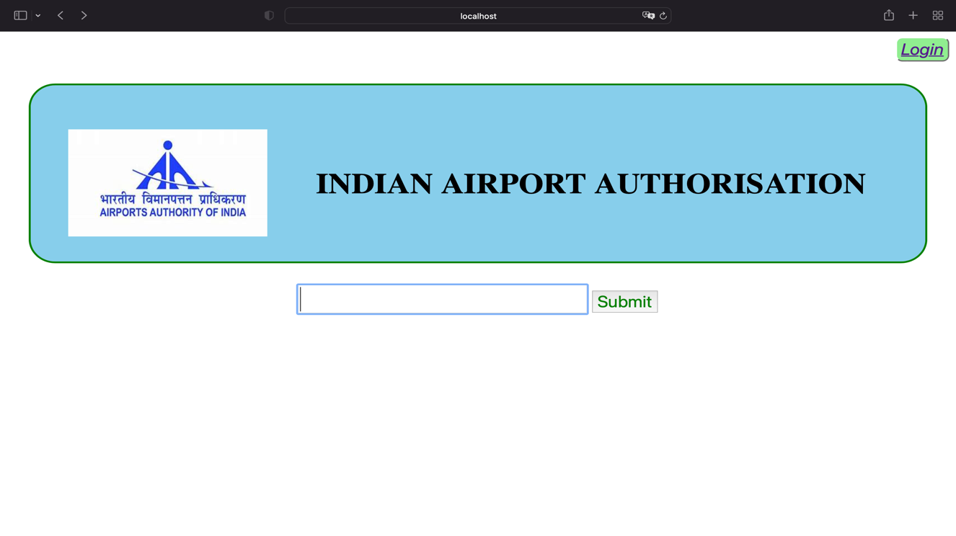

Figure 6: User Interface.

After scanning the passport, the passport number will automatically be been filled in the text box and been submitted.

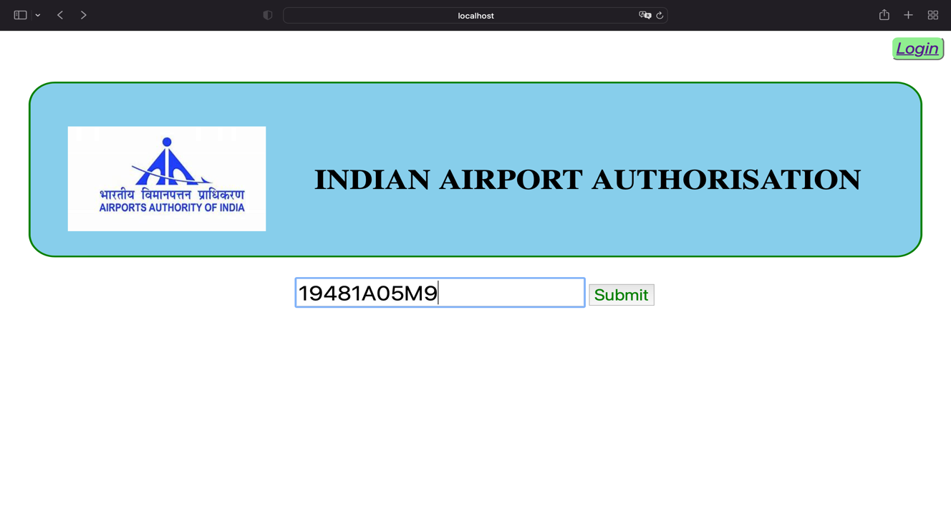

Figure 7: User Interface After scanning.

If it is a valid or invalid passport number then a popup will be displayed accordingly.

**Success:**

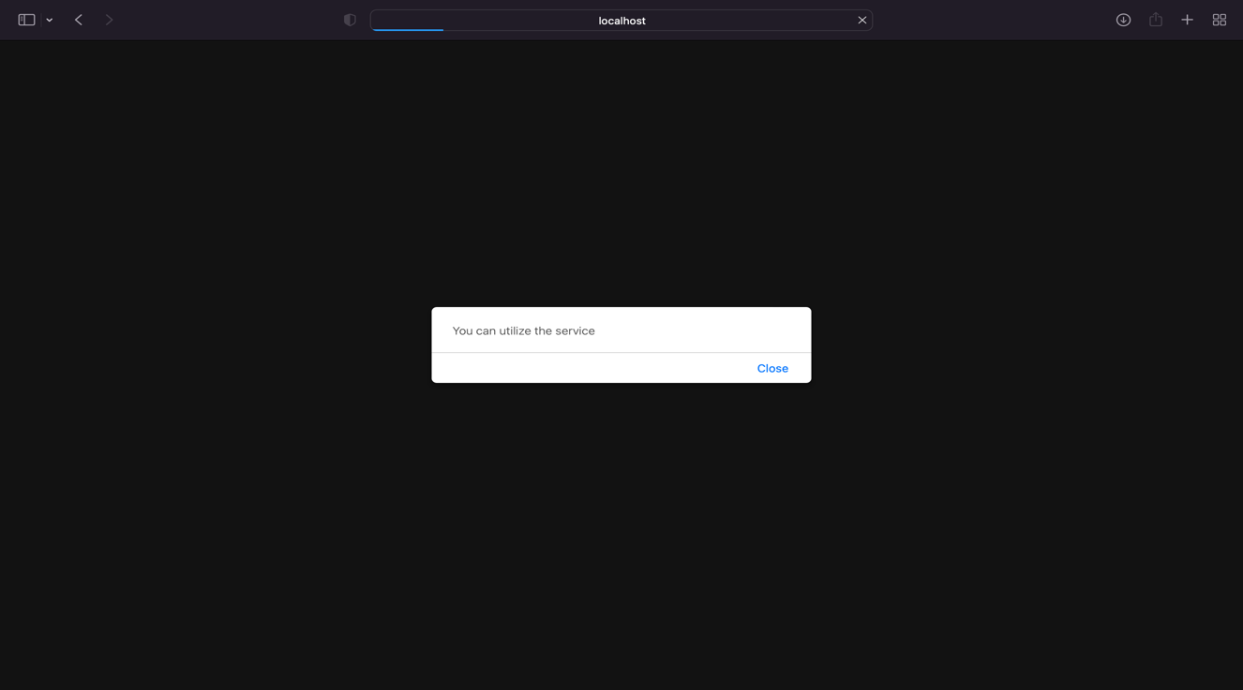

Figure 8: After successful scanning result.

**Error:**

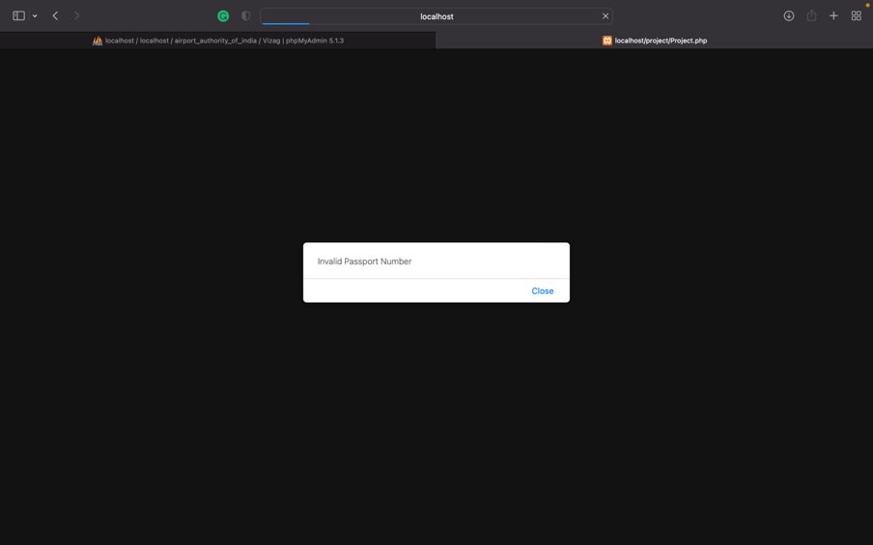

Figure 9: After Failure of scanning result.

**Authority Login Page:**

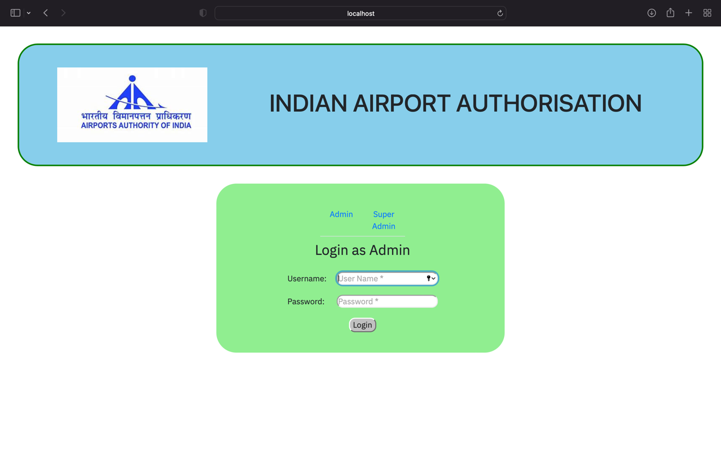

Figure 10: Initial opening of Website.

**Super admin page:**

When the super admin wants to logins the webpage then they must first select the login button in user page and should be selecting the super admin option and they need to give the correct credentials.

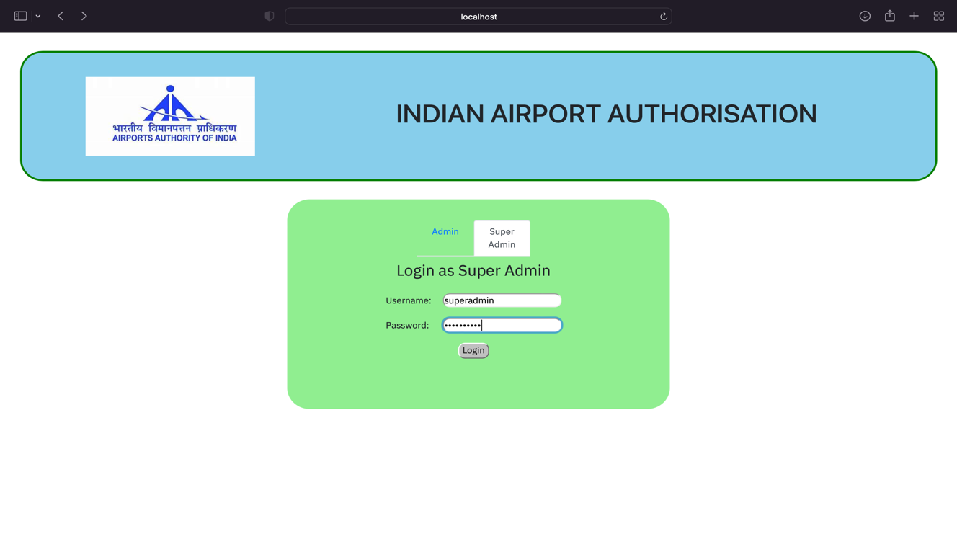

Figure 11: Trying to login as super admin.

If they are valid then the dashboard of super admin will be displayed or if they are invalid credentials then a popup will be displayed.

**Success:**

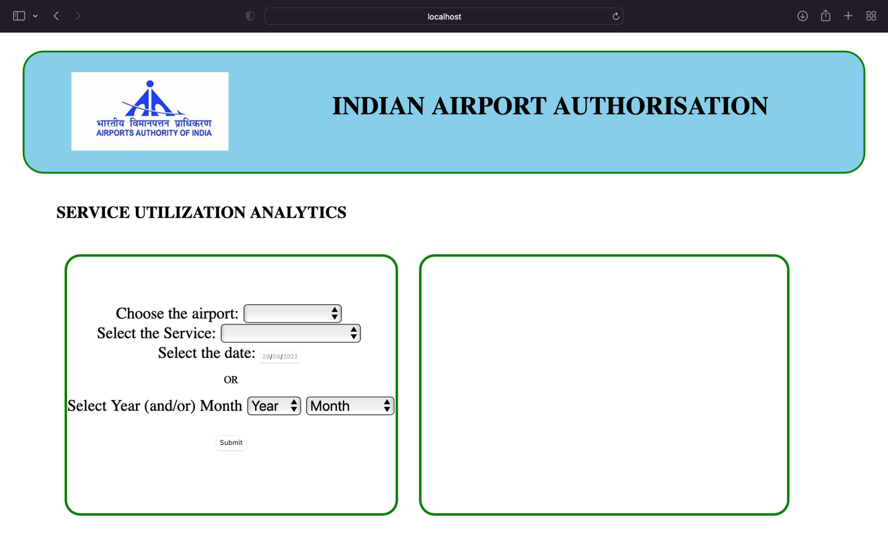

Figure 12: After logging successfully as super admin.

**Error:**

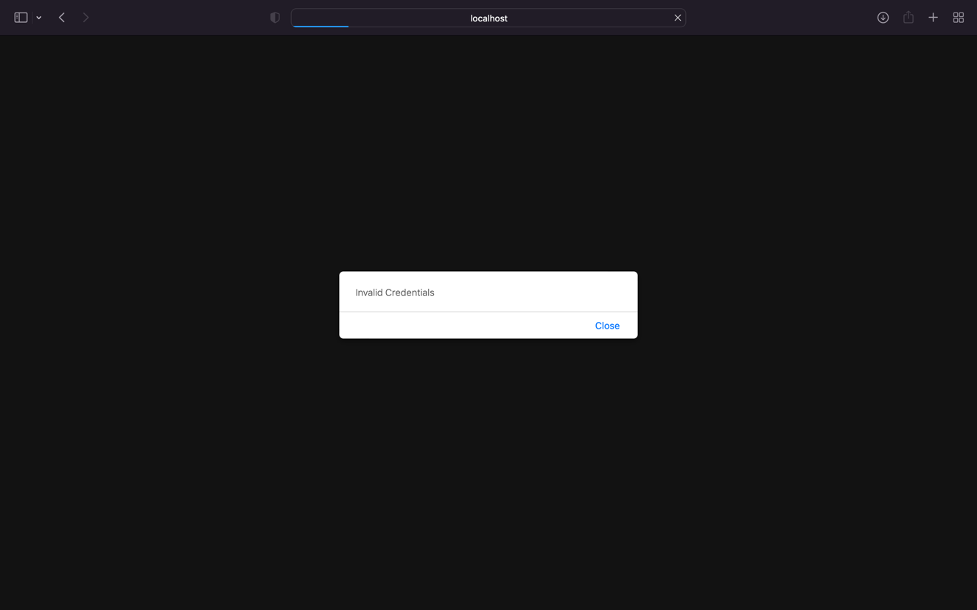

Figure 13: Failure when logging as super admi.

After successful logging in, the query will be selected one by one. Let us take the example of we want to know the utilization of trollies at vizag airport in the month of April 2022. Then, If the query is valid then a pie chart is displayed or else an error message is printed.

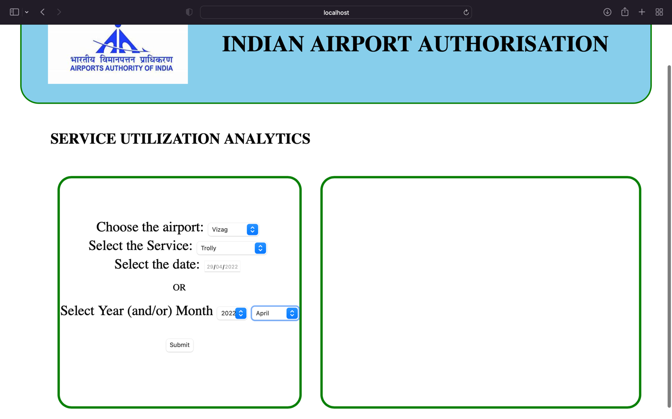

Figure 14: After selecting a query in super admin.

**Success:**

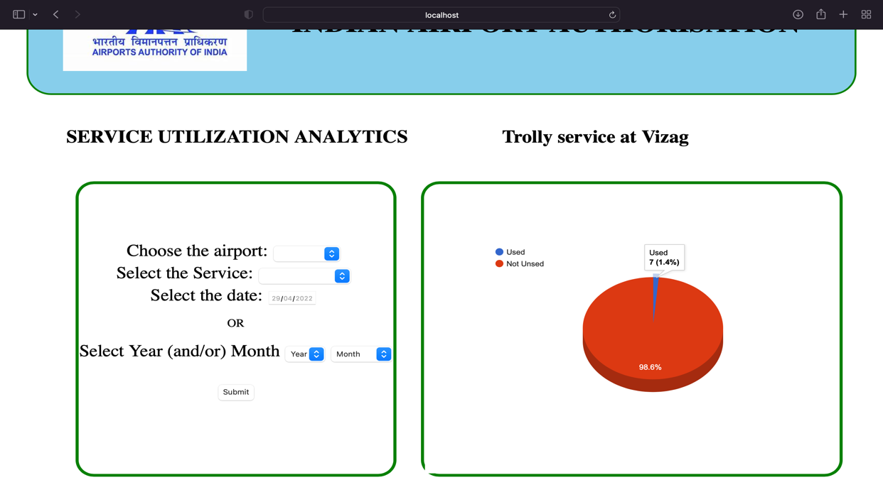

Figure 15: After a successful query execution.

**Error:** If the airport or service or the inappropriate date format i.e., mentioning only month without a year is selected then it results in “**Invalid Request**”.

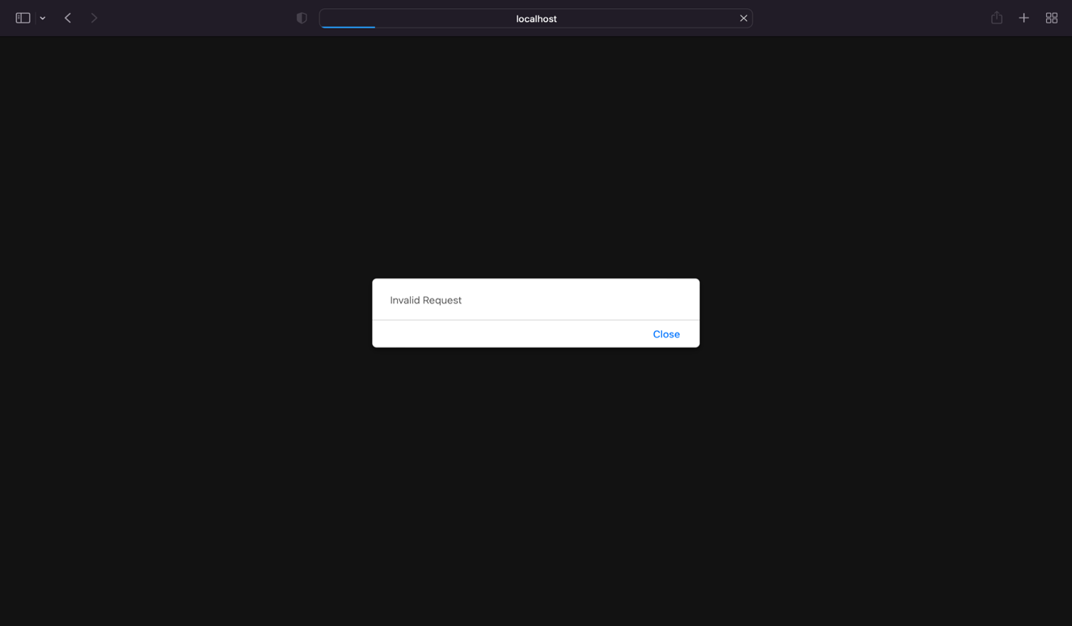

Figure 16: After an unsuccessful query execution.

**Admin page:**

When the admin wants to login to the webpage then they must be selecting the admin option and they need to give the correct credentials.

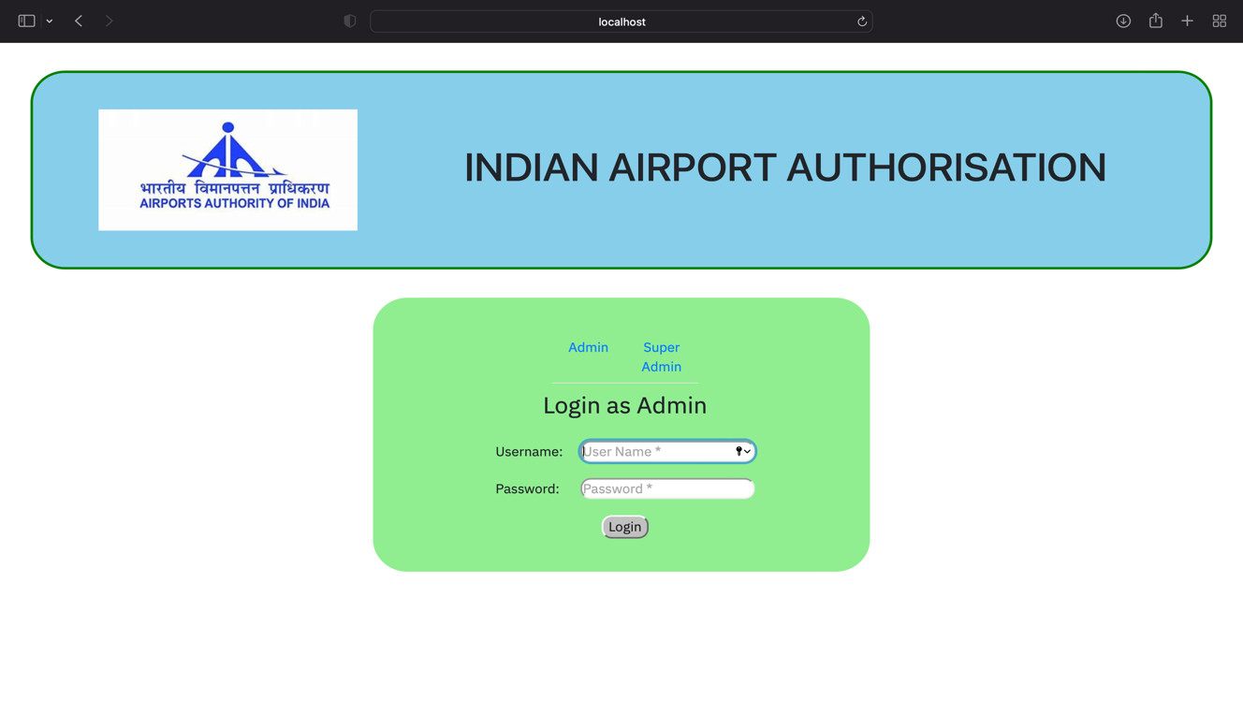

Figure 17: View of admin page.

If they are valid then the dashboard of admin will be displayed or if they are invalid credentials then a popup will be displayed. Let us take we are login in as vizag airport authority.

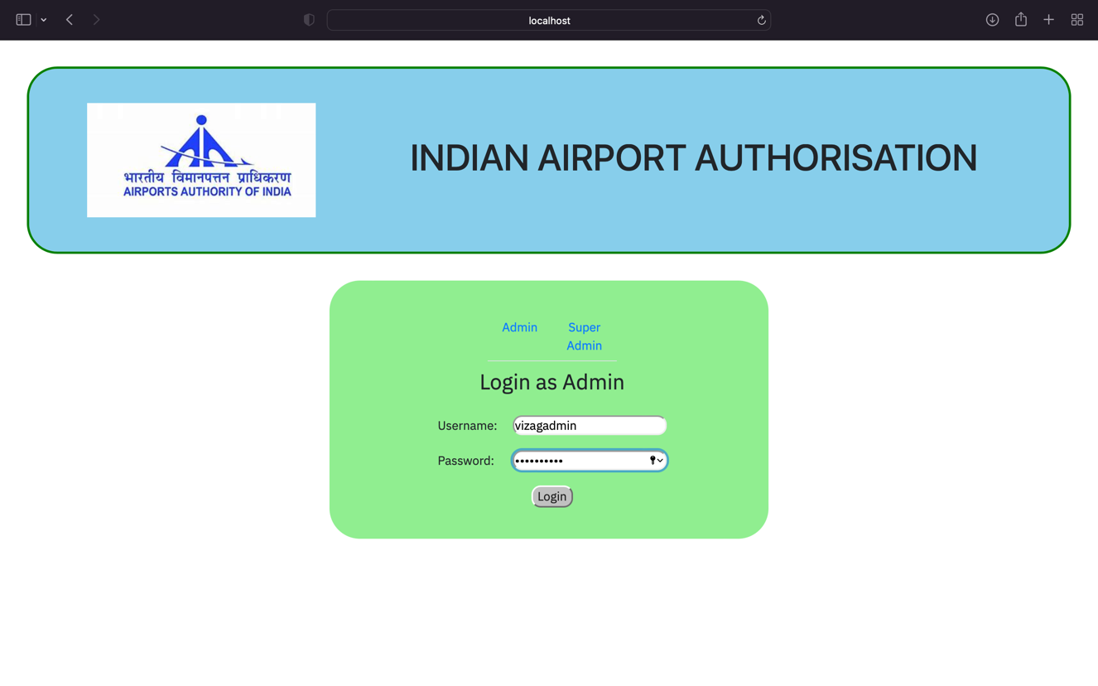

Figure 18: Trying to login as admin.

**Success:**

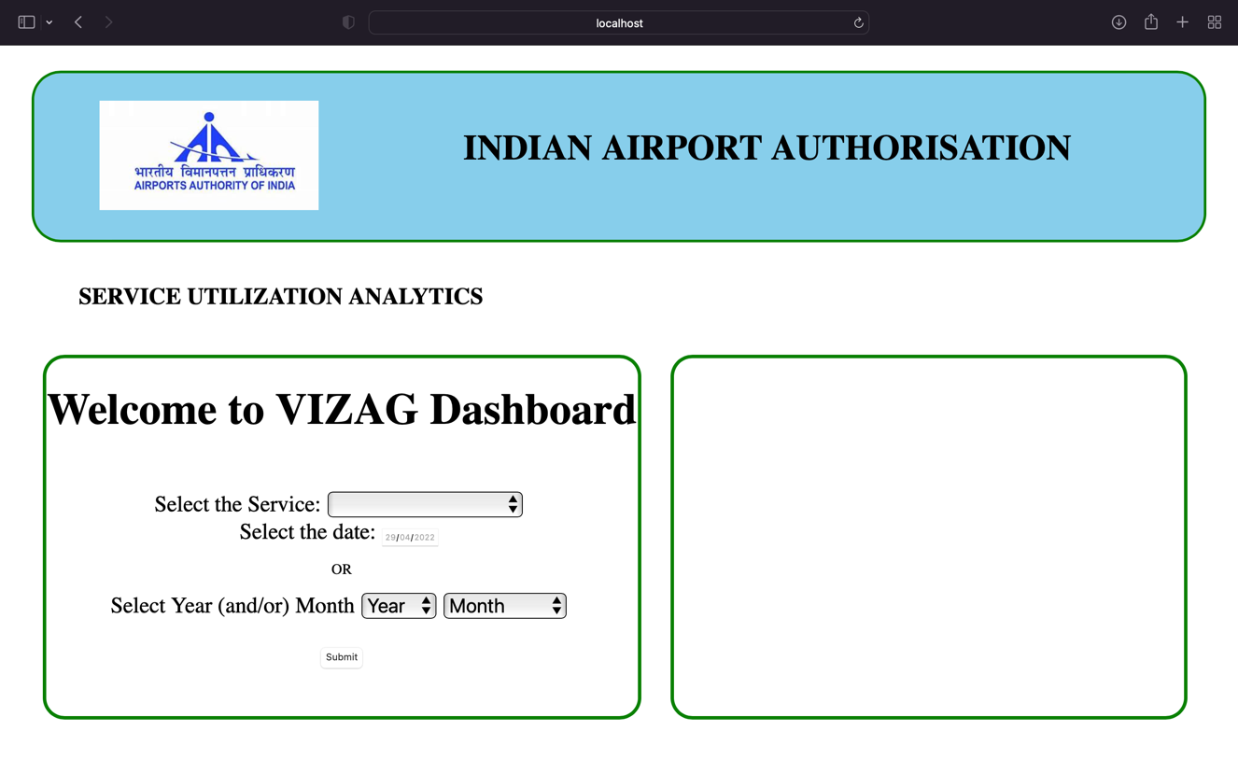

Figure 19: After logging successfully as admin.

**Error:**



Figure 20: Failure when logging as admi.

After successful logging in, the query will be selected one after the other. Let us take the example, if we want to know the utilization of trollies in the month of April 2022. Then, if the query is valid then a pie chart is displayed or else an error message is printed.

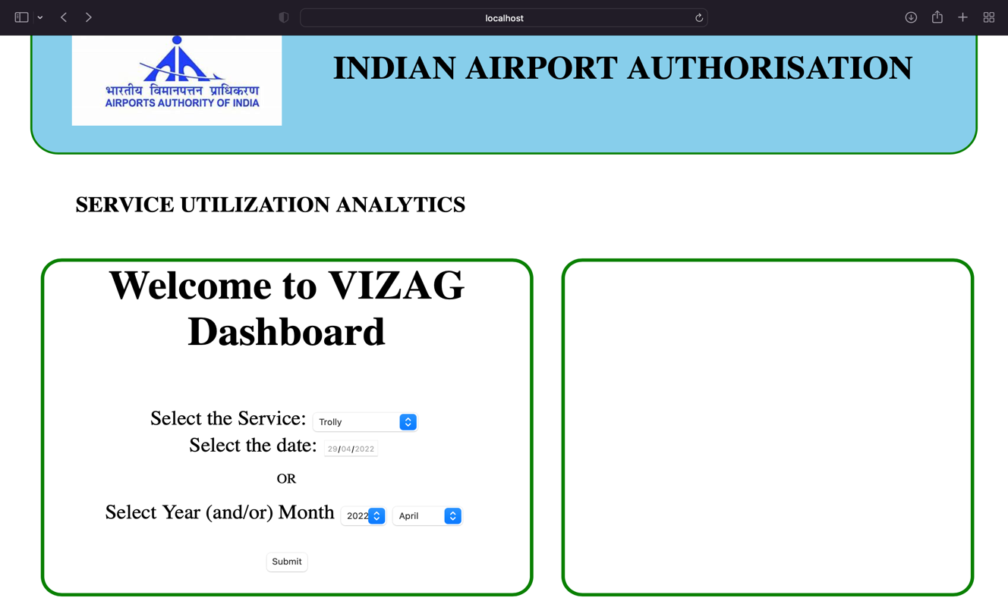

Figure 21: After selecting a query in admin.

**Success:**

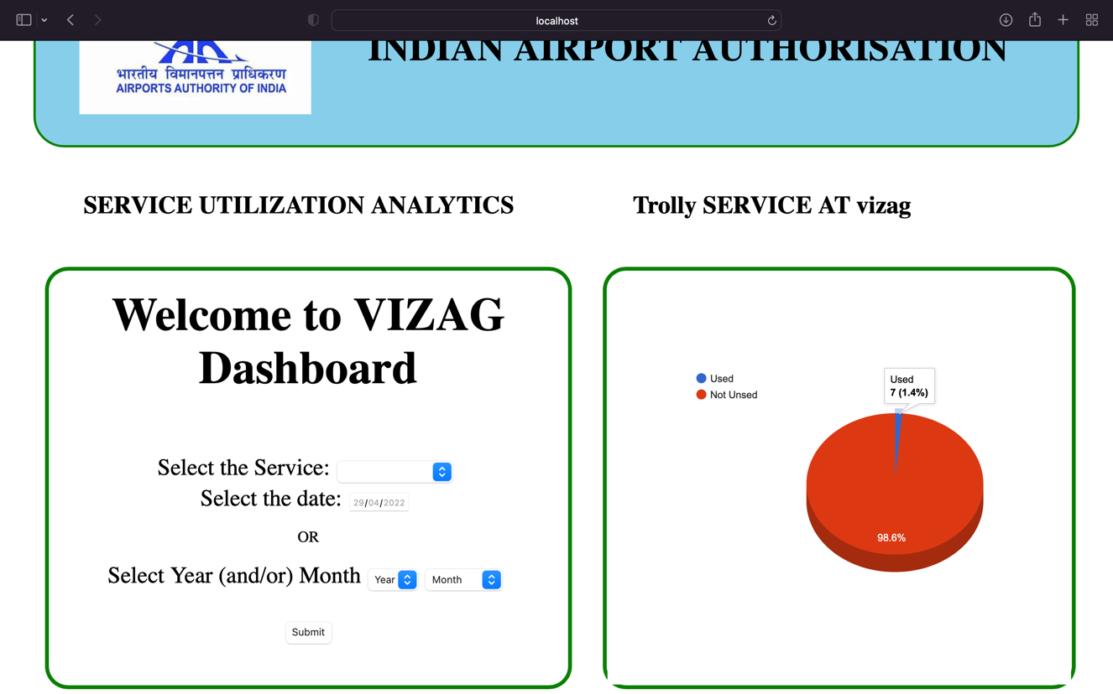

Figure 22: After a successful query execution.

**Error:** If the service or the inappropriate date format i.e., mentioning only month without a year is selected then it results in “**Invalid Request**”.

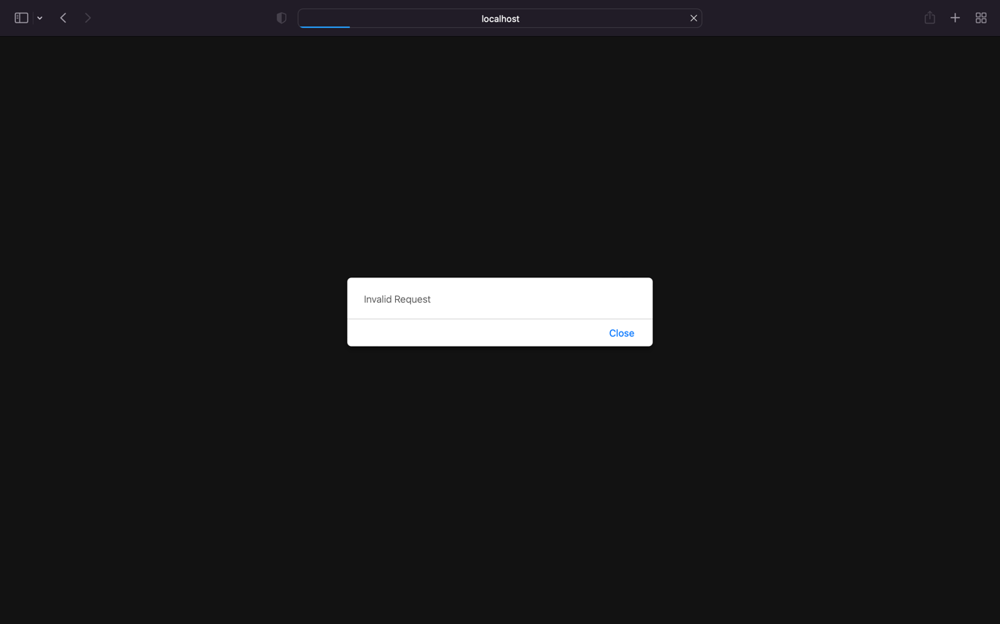

Figure 23: After an unsuccessful query execution.

**SESHADRI RAO GUDLAVALLERU ENGINEERING COLLEGE**

(An Autonomous Institute with Permanent Affiliation to JNTUK, Kakinada)

Seshadri Rao Knowledge Village, Gudlavalleru

**Department of Computer Science and Engineering**

**Program Outcomes (POs)**

**Engineering Graduates will be able to:**

1. **Engineering knowledge**: Apply the knowledge of mathematics, science, engineering fundamentals, and an engineering specialization to the solution of complex engineering problems.
2. **Problem analysis**: Identify, formulate, review research literature, and analyze complex engineering problems reaching substantiated conclusions using first principles of mathematics, natural sciences, and engineering sciences.
3. **Design/development of solutions**: Design solutions for complex engineering problems and design system components or processes that meet the specified needs with appropriate consideration for the public health and safety, and the cultural, societal, and environmental considerations.
4. **Conduct investigations of complex problems**: Use research-based knowledge and research methods including design of experiments, analysis and interpretation of data, and synthesis of the information to provide valid conclusions, component, or software to meet the desired needs.
5. **Modern tool usage**: Create, select, and apply appropriate techniques, resources, and modern engineering and IT tools including prediction and modelling to complex engineering activities with an understanding of the limitations.
6. **The engineer and society**: Apply reasoning informed by the contextual knowledge to assess societal, health, safety, legal and cultural issues and the consequent responsibilities relevant to the professional engineering practice.
7. **Environment and sustainability**: Understand the impact of the professional engineering solutions in societal and environmental contexts, and demonstrate the knowledge of, and need for sustainable development.
8. **Ethics**: Apply ethical principles and commit to professional ethics and responsibilities and norms of the engineering practice.
9. **Individual and team work**: Function effectively as an individual, and as a member or leader in diverse teams, and in multidisciplinary settings.
10. **Communication**: Communicate effectively on complex engineering activities with the engineering community and with society at large, such as, being able to comprehend and write effective reports and design documentation, make effective presentations, and give and receive clear instructions.
11. **Project management and finance**: Demonstrate knowledge and understanding of the engineering and management principles and apply these to one’s own work, as a member and leader in a team, to manage projects and in multidisciplinary environments.
12. **Life-long learning**: Recognize the need for, and have the preparation and ability to engage in independent and life-long learning in the broadest context of technological change.

**Program Specific Outcomes (PSOs)**

PSO1: Design, develop, test and maintain reliable software systems and intelligent systems.

PSO2: Design and develop web sites, web apps and mobile apps.

**PROJECT PROFORMA**

|  |  |  |  |  |
| --- | --- | --- | --- | --- |
| **Classification**  **of**  **Project** | **Application** | **Product** | **Research** | **Review** |
| √ |  |  |  |

**Note: Tick Appropriate category**

|  |  |
| --- | --- |
| **Project Outcomes** | |
| Course Outcome  (CO1) | Identify and analyze the problem statement using prior technical knowledge in the domain of interest. |
| Course Outcome  (CO2) | Design and develop engineering solutions to complex problems by employing systematic approach. |
| Course Outcome  (CO3) | Examine ethical, environmental, legal and security issues during project implementation. |
| Course Outcome  (CO4) | Prepare and present technical reports by utilizing different visualization tools and evaluation metrics. |

**Mapping Table**

|  |  |  |  |  |  |  |  |  |  |  |  |  |  |  |  |
| --- | --- | --- | --- | --- | --- | --- | --- | --- | --- | --- | --- | --- | --- | --- | --- |
| **CS2515 : MINI PROJECT** | | | | | | | | | | | | | | | |
| **Course Outcomes** | **Program Outcomes and Program Specific Outcomes** | | | | | | | | | | | | | | |
| **PO 1** | **PO 2** | **PO 3** | **PO 4** | **PO 5** | **PO 6** | **PO 7** | **PO 8** | **PO 9** | **PO 10** | **PO 11** | **PO 12** |  | **PSO 1** | **PSO 2** |
| CO1 | 3 | 3 | 3 | 1 |  | 3 | 3 | 2 | 2 | 2 |  | 3 |  | 3 | 3 |
| CO2 | 3 | 3 | 3 | 3 | 3 | 3 | 3 | 2 | 3 | 2 |  | 3 |  | 3 | 3 |
| CO3 | 2 | 2 | 3 | 2 | 2 | 3 | 3 | 3 | 3 | 1 | 2 | 3 |  | 3 | 3 |
| CO4 | 2 |  | 1 | 2 | 3 | 3 |  |  | 3 | 1 | 2 | 3 |  | 3 | 3 |

**Note: Map each project outcomes with POs and PSOs with either 1 or 2 or 3   
 based on level of mapping as follows:**

1-Slightly (Low) mapped 2-Moderately (Medium) mapped 3-Substantially (High) mapped